**Final Project Queries**

**Query 1: What large acquisitions (greater than $3 billion) has Cisco made?**

MATCH (:Competing_Company {name: "Cisco Systems"})-[:Acquired]->(a:`Acquired_Company`)

WHERE a.`Value (USD)` > 3000000000

RETURN a.name AS Big_Acquisitions, a.`Value (USD)` AS Acquisition_Price

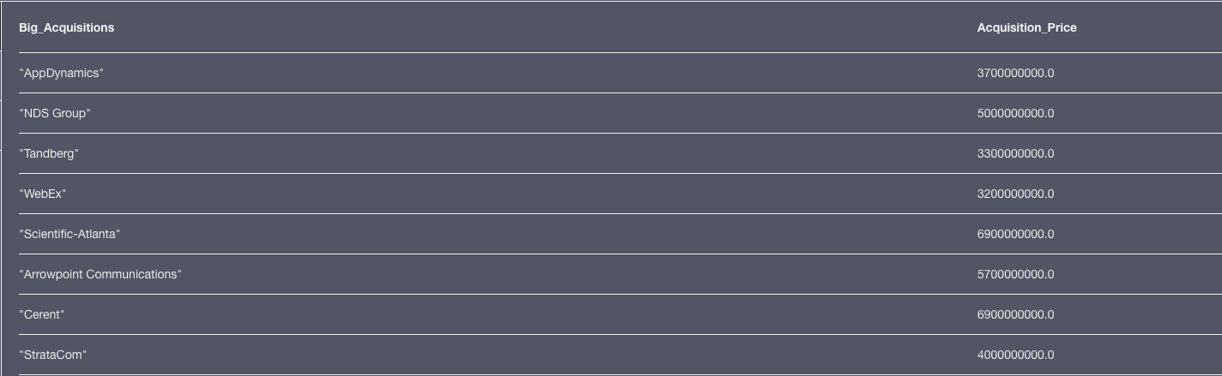

**Query 2: Who has Cisco acquired in the last three years?**

MATCH (A:Acquired_Company) WHERE A.Date > 2016

RETURN A.name as Company_Name, A.Date as Acquired_Date

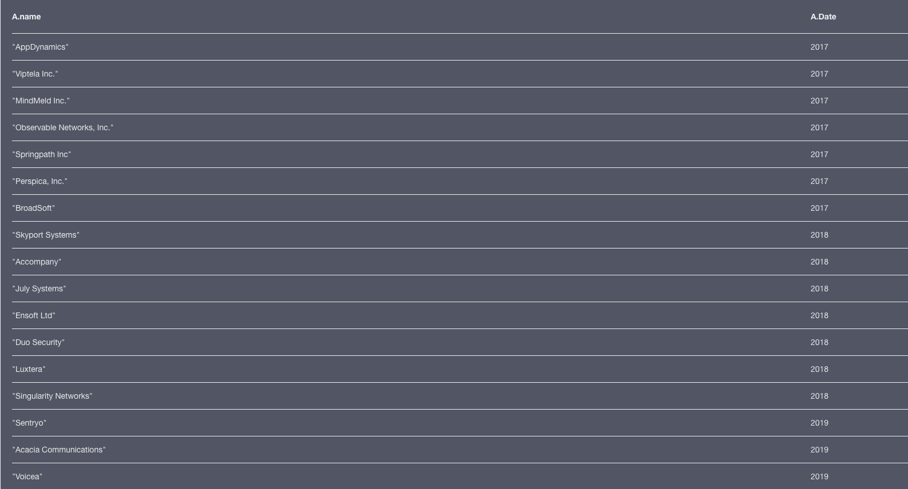

**Query 3: How many CEOs of competing companies are female and have Masters education or greater?**

**MATCH (:Competing_Company)-[e:Employee]->(p:Person)**

**WHERE p.Gender = "Female"**

**AND ("MBA" in p.`Highest Degree` OR "M.S." in p.`Highest Degree`)**

**RETURN p.name as CEO, p.`Highest Degree` as Highest_Degree**

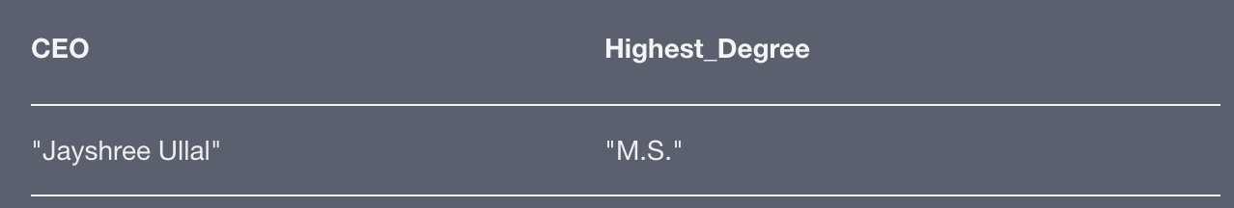

**Query 4: As a money manager designing a risk-averse portfolio, which public companies have relatively low price/earning ratio, high operating income, mid-to-large market capitalization, and relatively low volatility (beta)?**

**MATCH (c:Competing_Company)-[:Has_Financials]->(f:Financials)**

**WHERE exists(f.stock_symbol)**

**AND f.operating_income > 500000000**

**AND f.market_cap > 1000000000**

**AND f.pe_ratio < 20**

**AND f.beta < 1.3**

**RETURN f.name as Company, f.stock_symbol as Stock, f.price as Current_Price, f.beta as Volatility**

**ORDER BY Volatility**

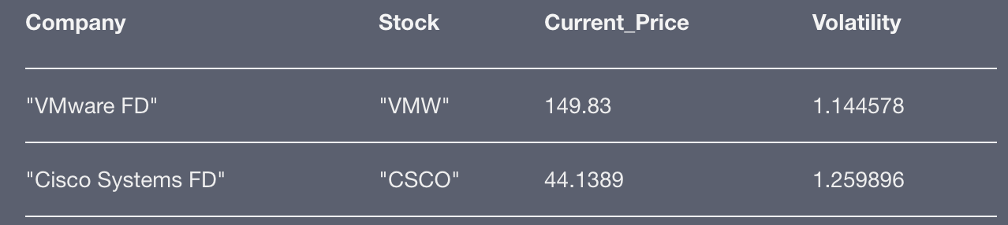

**Query 5: If we utilize % Overlap of competing companies to identify Cisco Systems main competitor and utilize the reason for Overlap to identify Cisco’s main business. Can we identify the total number of competing companies in the same business that Cisco has acquired?**

**MATCH ()-[c:Competitor]-() with max(c.`% Overlap`) as max_overlap**

**MATCH ()-[c:Competitor]-(company) WHERE c.`% Overlap` = max_overlap and not company.name ='Cisco Systems' with c.Reason as overlap_reason**

**MATCH ()-[c:Acquired]-(aquired_companies) WHERE c.Reason = overlap_reason RETURN overlap_reason, count(aquired_companies)**

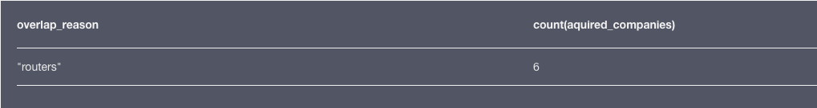

**Query 6: Which CEOs have done the worst job in ensuring their company has a substantial online following (>20k followers) along with a positive sentiment in Twitter?**

**MATCH (p:Person)<-[:Employee]-(c:Competing_Company)-[:Social_Media_Presence]->(s:Social_Media)**

**WHERE s.sentiment_polarity < 0.2**

**AND s.`Twitter followers` < 20000**

**RETURN p.name as CEO,c.name as Company, s.sentiment_polarity as Twitter_Sentiment, s.`Twitter followers` as Followers**

**ORDER BY Twitter_Sentiment**

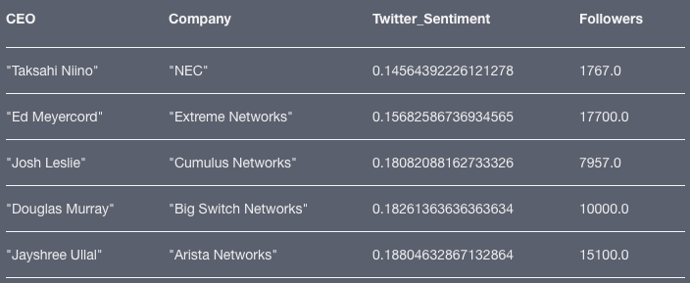

**Query 7: Based on products extracted from Wikipedia text, Which company is the leanest in terms of revenue per employee? Number of employees working on each product?**

**MATCH (c:Competing_Company)-[:Provides]->(p:Products)**

**WITH c, c.`# Employees` as Employees, count(p) as product_count**

**WHERE product_count > 0**

**RETURN c.name as Company, product_count,**

**Employees, (Employees/product_count) as Employee_per_Product,**

**(c.`Revenue (B)` / Employees) as Revenue_per_employee**

**ORDER BY (CASE Revenue_per_employee WHEN null THEN {} ELSE Revenue_per_employee END) DESC**

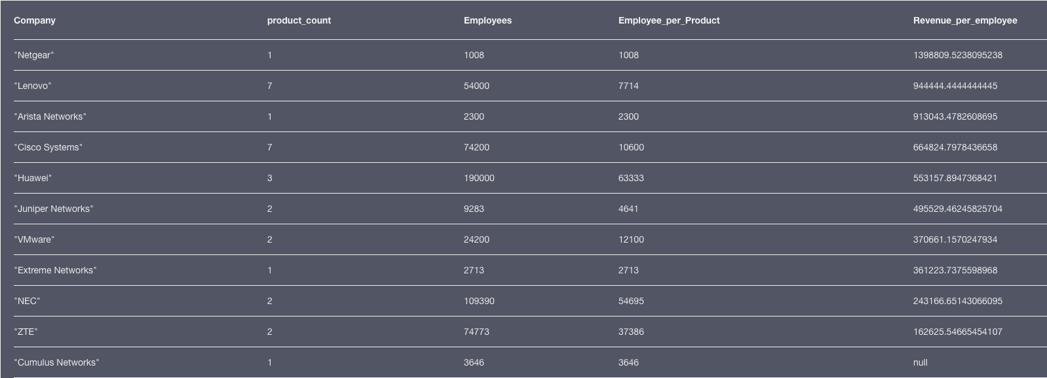

**Query 8: For each 2 digit Parent code for NAICS codes, what is the total number of services provided by the companies linked to them?**

**MATCH (N:NAICS_Code)<-[: NAICS_Code_Subset_of]-(n)<-[: Company_NAICS_code]-(C: Competing_Company)-[: Provides]->(S: Services) RETURN N.Code as Parent_Code, count(S) as Services_per_Parent_Node**

